- Create user with name Techie and provide Sudo access to user.
Objective
To create a new Linux user account and grant administrator privileges using sudo access
from root user execute following
To create new user
Command: useradd Techie
To create user, we use

Add User
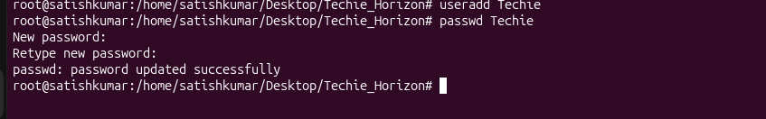
To check Sudo files
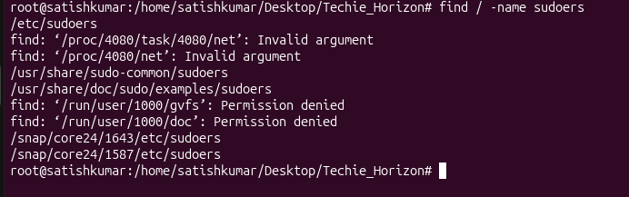
Add sudo
Command : vi/etc/sudoers ----ENTER
vi /etc/sudoers
Techie ALL=(ALL:ALL) ALL
esc
:wq!

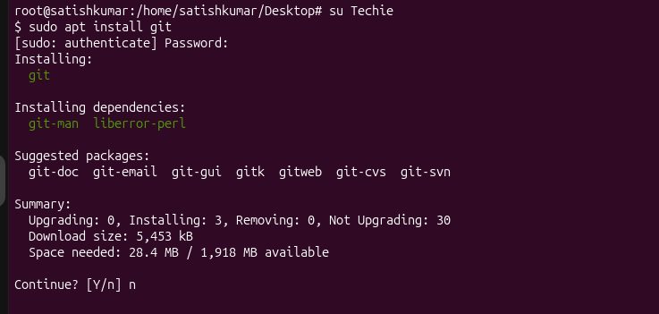
- Navigate to the home directory.
Objective:

To move to the current user's home directory.

Commands Executed
Command : cd ~
Command : pwd

Command Output
/home/satishkumar


Key Learnings
- cd changes directories.
- ~ represents the user's home directory.
- pwd displays the current location.

- Create a new directory.
Objective
To create a new directory for storing files.

Commands Executed
mkdir task1
ls
Command Output
task1

Created directory task1

Key Learnings
- mkdir creates a new directory.
- Directories help organize files efficiently.

- List the contents of a directory.
Objective
To display all files and folders in the current directory.

Commands Executed
ls

Command Output
Displays available files and directories

Key Learnings
- ls lists directory contents.
- Useful for checking file and folder availability.

- Change the current directory.
Objective
To move from one directory to another.

Commands Executed
cd task1
pwd

Command Output
/home/ubuntu/task1

Key Learnings
- cd changes the current directory.
- pwd confirms the current path.

- Create a new empty file.
Objective
To create an empty text file.
Commands Executed
touch myfile2
ls
Command Output
myfile2
Key Learnings
- touch creates a new empty file.
- Commonly used for creating scripts

- View the contents of a file.
Objective
To display the contents of a text file.
Commands Executed
Add sample content
echo "Hello world" > myfile2
View content:
cat myfile2
Command Output
Hello hari
Key Learnings
- cat displays file contents.
- Useful for verifying stored information


- Copy a file to another location.
Objective
To create a duplicate copy of a file.
Commands Executed
cp myfile2 /home/satishkumar/task1
ls
Command Output
123
Key Learnings
- cp copies files and directories.
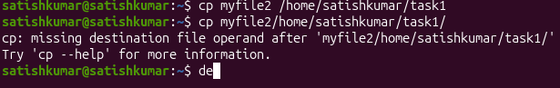
- Move a file to another location.
Objective
To transfer a file from one directory to another.
Commands Executed
Touch
mkdir
mv
Verification:
ls
Command Output
myfile
Key Learnings
- mv moves files and directories.
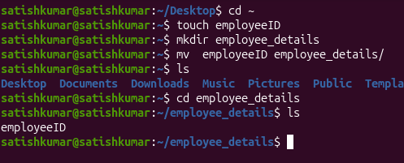

- Rename a file.
Objective
To change the name of an existing file.
Commands Executed
mv Techie_Horizon Techie

Verification:
ls
Command Output
Techie
Key Learnings/Notes
- mv can also be used for renaming files.
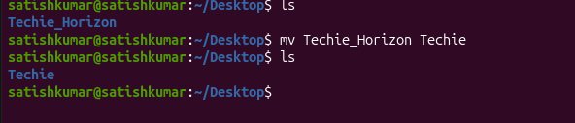
- Delete a file.
Objective
To permanently remove an unwanted file from the Linux file system.
Commands Executed
rm myfile
Verify deletion:
ls
Command Output
The myfile is removed successfully and no longer appears in the directory listing.
Evidence (Screenshots)
Key Learnings
- rm permanently deletes files.
- Deleted files cannot be recovered easily.
- Use the command carefully
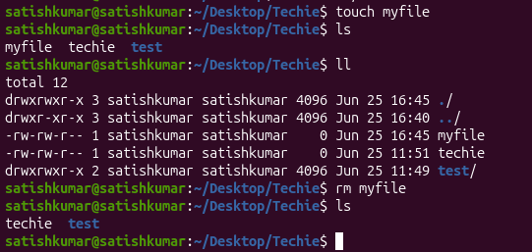
- Grant or revoke permissions on a file or directory.
Objective
To control who can read, write, or execute a file.
Commands Executed
Create a file:
touch file02
Grant permissions:
chmod 771 file02
Verify permissions:
ls -l
Command Output
-rwxrwxr--x 1 satishkumar satishkumar 0 Jun 28 file02
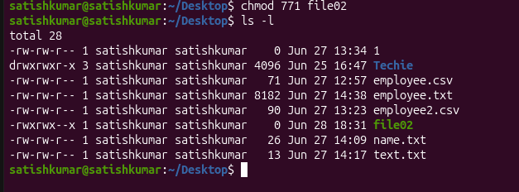
Key Learnings
chmod changes file permissions.
- 771gives:
- Owner: Read, Write, Execute
- Group: Read, Write, Execute
- Others: Execute

- View the current date and time.
Objective
To display the current system date and time.
Commands Executed
date
Command Output
Thu Jun 25 05:08:46 PM EDT 2026
Key Learnings
  - date displays the current system date and time.
  - Useful for checking timestamps and logs.

- Check the system uptime.
Objective
To determine how long the system has been running since the last boot.
Commands Executed
uptime
Command Output
18:42:32 up 36 min, 1 user, load average: 0.32, 0.09, 0.11
Key Learnings
  - uptime shows system running time.
  - Displays current users and system load.
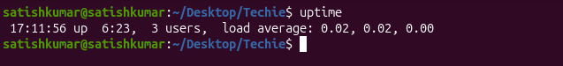

- View the running processes.
Objective
To display all currently running processes.
Commands Executed
ps -ef
Command Output
Displays a list of running processes with Process IDs (PIDs).
Key Learnings
  - ps displays process information.
  - -e shows all processes.
  - -f displays detailed information.
Displays running processes and updates continuously.
1.Command: ps -ef
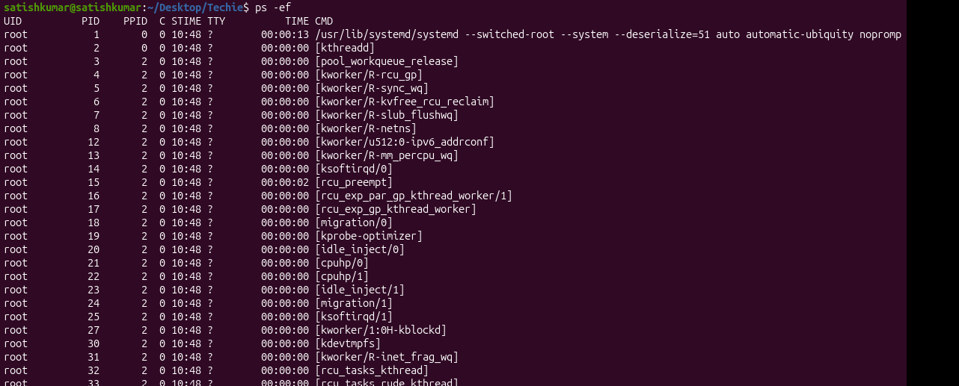
Purpose: check how many services are running in my machine.

2.Command: top
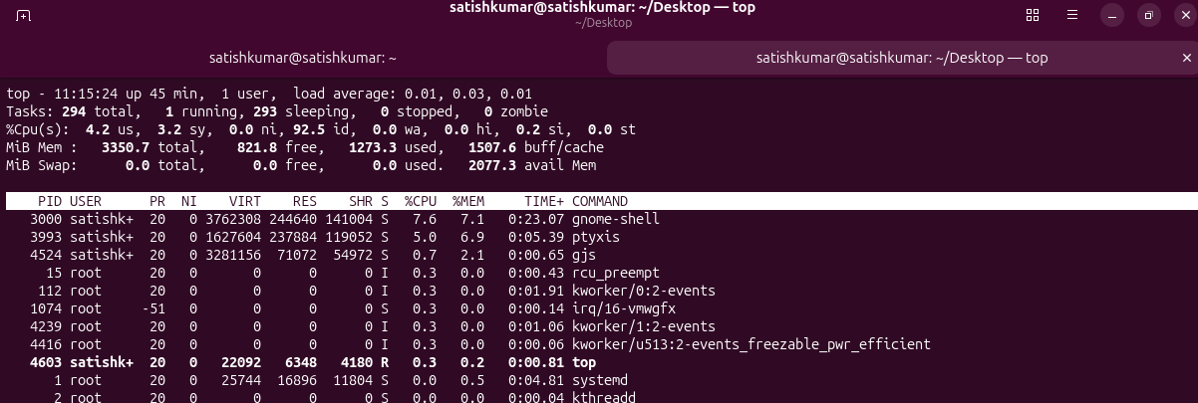
Purpose: to check CPU utilization.

Press q to quit.
- Kill a running process.
Objective
To stop a running process using its Process ID (PID).
Commands Executed
ps -ef
Kill the process:
kill PID
Force kill (if needed):
kill -9 PID
Command Output
- The selected process stops running successfully.
- Screenshot showing the PID.
- Screenshot of the kill command.
- Screenshot verifying the process is no longer running.
Key Learnings/Notes
  - kill terminates a process gracefully.
  - kill -9 forcefully terminates a process.
Command : sudo kill -9 <PID>
Use to forcefully terminate (kill) a running process.
kill -9 forcefully terminates a process without allowing it to clean up or save its work. It's better to try
kill <PID> (SIGTERM) first, and use kill -9 only if the process doesn't respond.

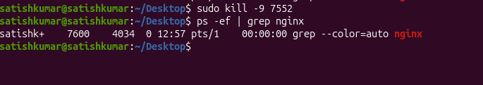
Status :
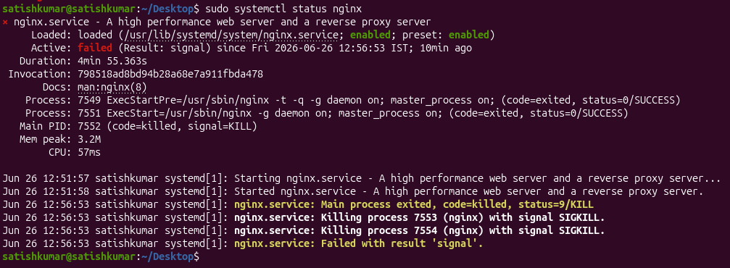
- Install a package using the package manager (e.g., apt or yum).
Objective
To install software packages using the APT package manager.
Commands Executed
Install package:
sudo apt install nginx
Command Output
The nginx package is installed successfully.
Evidence (Screenshot)
sysy
Key Learnings
  - apt install installs software packages.
For Ubuntu package manager = apt
For Linux package manager = yum
Used to check whether the nginx process is running.
Command : ps -ef | grep nginx
ps = Displays running processes.
-e = Shows all processes.
-f = Displays the full format (PID, PPID, user, start time, command, etc.).
|
- This is the pipe (|) operator.
- It sends the output of ps -ef as input to the next command.
grep nginx
- grep searches for lines containing the word nginx.

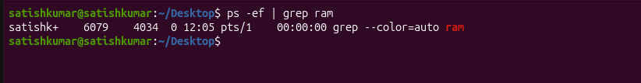
Note: Showing nothing because ram package not available in package manager
If there is no output, it simply means no process with that name is running.
Install packages
Command: sudo apt install nignix
Purpose of the command
sudo apt install nginx
- sudo → Runs the command with administrator (root) privileges.
- apt → Ubuntu/Debian package manager used to install, update, and remove software.
- install → Tells apt to install a package.
- nginx → The package name of the NGINX web server.
This command downloads and installs the NGINX web server on your Ubuntu/Linux system.
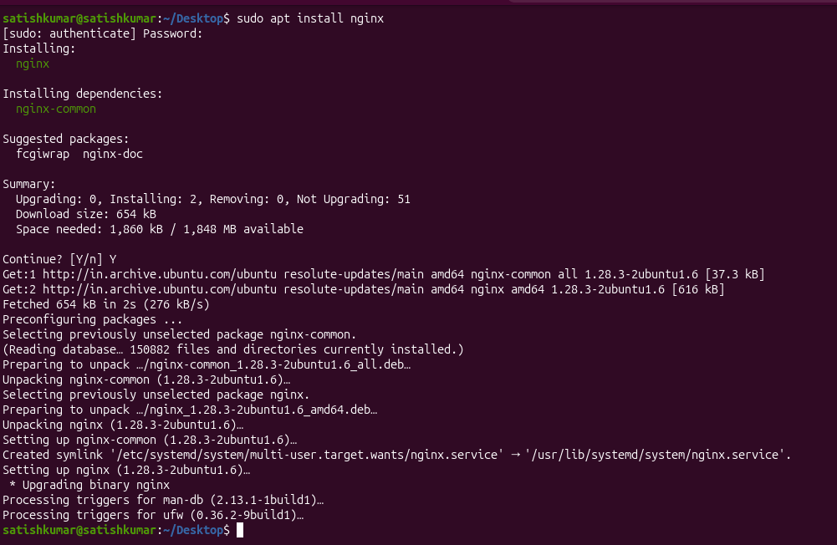
Run packages
Command: sudo systemctl start nignix
Check Status
Command: sudo systemctl status nignix
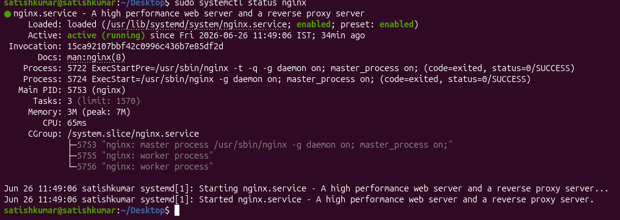

To check package running
Command: ps -ef | grep nginx
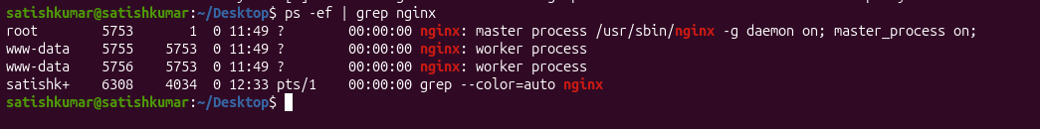
To stop services
Command: sudo systemctl stop nginx

Check
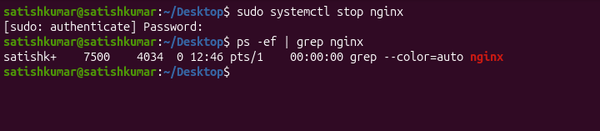
Command: ps -ef | grep nginx

- Update the system packages.
Objective
To update installed packages with the latest available versions.
Commands Executed
sudo apt update
Command Output
The system package list is updated, and installed packages are upgraded.
Key Learnings
- apt update refreshes package information.
- apt upgrade installs available updates.
Purpose
- sudo → Runs the command with administrator (root) privileges.
- apt → Package manager used in Ubuntu/Debian.
- update → Downloads the latest list of available packages from the configured software repositories.
explanation:
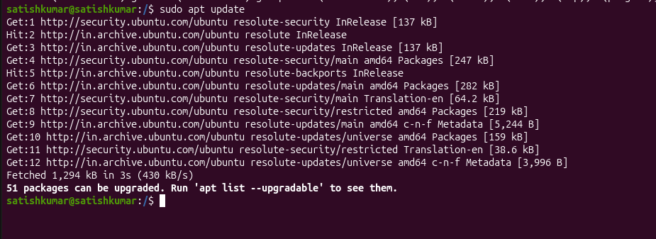
This command does not install any updates. It only refreshes the list of available package versions so your system knows what updates are available.

- Create a symbolic link.
Objective
To create a shortcut that points to another file.
Commands Executed
Create original file:
touch satish
Create symbolic link:
ln -s satish shortcut.txt
Verify:
ls -l
Command Output
shortcut.txt -> original.txt
Key Learnings
- ln -s creates a symbolic (soft) link.
- A symbolic link acts as a shortcut to the original file.
A symbolic link (symlink) is used to create a shortcut to another file or directory without copying it.

- Search for files using the find command.
Objective
To locate files or directories by name within the Linux file system.
Commands Executed
find /Desktop -name "Techie"
Command Output
/home/ubuntu/Desktop/Techie
Key Learnings
- find searches for files and directories.
- -name searches using the exact file name.
- Useful for locating files in large directory structures.
Purpose
- . → Search in the current directory.
- -name → Search by file name.
- "file.txt" → File to search for.

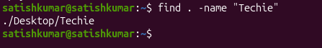

- Compress and decompress files using tar.
Objective
To compress multiple files or directories into a single archive and extract them when needed.
Commands Executed
Create an archive:
tar -cvf techie.test_tar
Extract the archive:
tar -xvf techie
Command Output
- test.tar archive is created successfully.
- The archive is extracted into the current directory.
Key Learnings
- tar is used to archive files and directories.
- -c = Create archive.
- -v = Verbose output.
- -f = Archive file name.
- -x = Extract archive
The tar command in Linux is used to archive multiple files and directories into a single file. It can also extract archived files. It is one of the most commonly used Linux commands.
Create compress file
Command: tar cvf techie.tar test_tar/
Purpose:
This command creates a TAR archive named techie.tar containing the entire test_tar directory.
-c option creates the archive,
-v displays the files being archived, and
-f specifies the output archive filename.
It is commonly used for backups and packaging multiple files into a single archive.
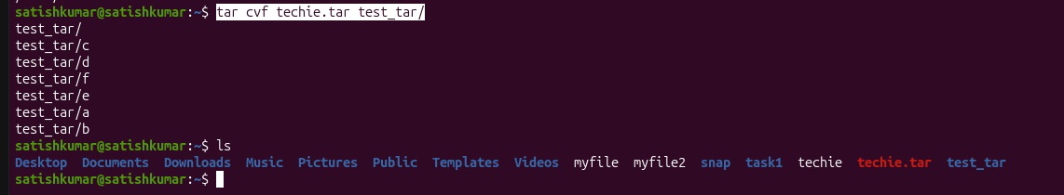
compress

decompress
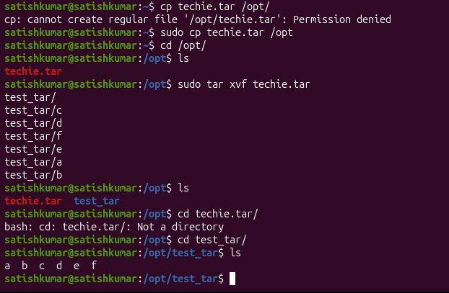
- Monitor system resources with top or htop.
Objective
To monitor CPU usage, memory usage, and running processes in real time.
Commands Executed
Using top:
Top
Command Output
Displays:
- CPU Usage
- Memory Usage
- Running Processes
Key Learnings
• top monitors system performance
The top and htop commands are used to monitor system resources in real time, such as CPU usage, memory usage, running processes, and system load.
top = Real-time system monitor.
htop = Enhanced (human-friendly) version of top.
Command : top
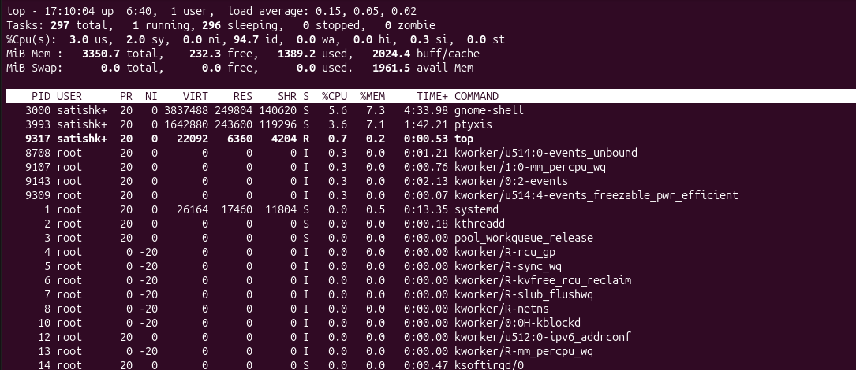
htop install and run
Command: sudo apt install htop
Command: htop
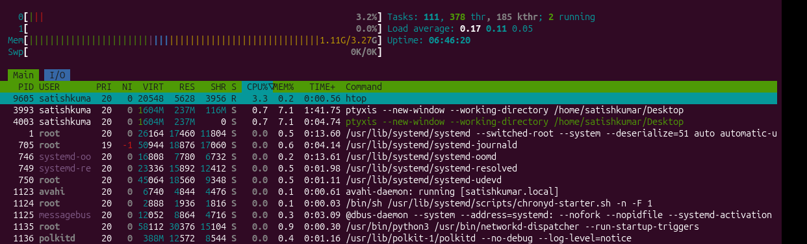
- Create and manage user groups.
Objective
A group in Linux is a collection of users. Groups are used to manage permissions and control access to files, directories, and system resources
Commands Executed
Create group:
sudo groupadd techie_devops
Add user:
sudo usermod -aG techie_devops Techie
Verify:
groups Techie
Command Output
Techie: Techie techie_devops
Key Learnings/Notes
- groupadd creates a new group.
- usermod -aG adds users to groups.
- Groups simplify permission management.
Step 1: Create a group
Command: groupadd techie_devops
.
Purpose:
- Organize users.
- Assign permissions to multiple users at once.
- Simplify user management


Step 2: Add a user to the group
Step 3: Verify
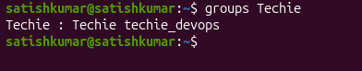
Step 4: Remove the user from the group
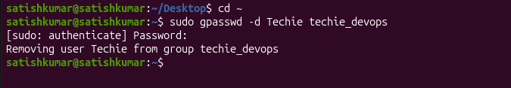

- Set up SSH password less authentication.
- Monitor log files using tail or grep.
Objective
To view and search log files for troubleshooting.
Commands Executed
View live logs:
tail -f /var/log/syslog
Command Output/Result
Displays recent log entries or matching log lines.
Key Learnings/Notes
- tail -f continuously monitors logs.

Log files record system events, application activity, errors, and warnings. Linux administrators and DevOps engineers use tail and grep to monitor and troubleshoot logs.
Command : tail -f /var/log/syslog
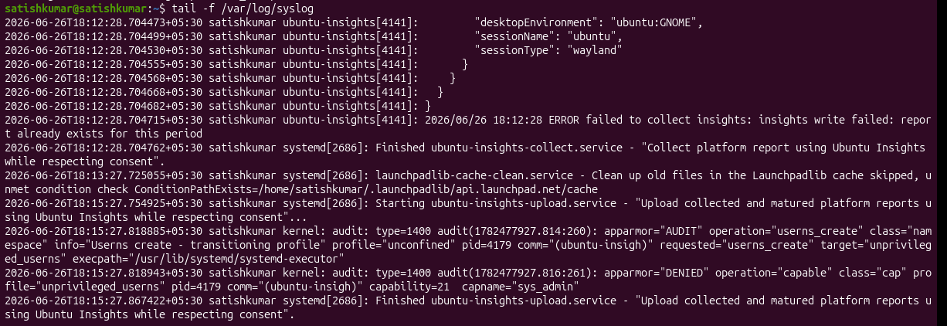
How to stop monitoring
Ctrl + C
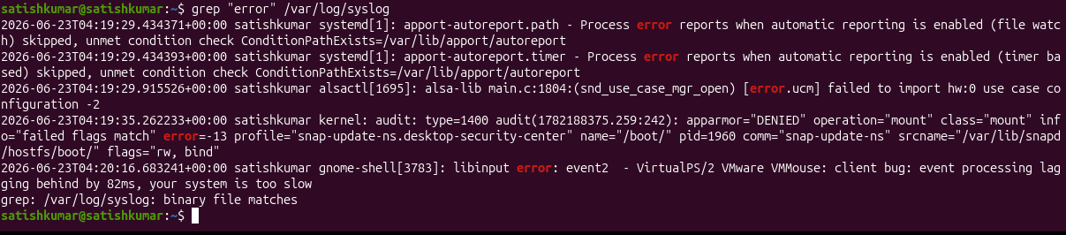
Command: tail -f /var/log/syslog | grep “satish”
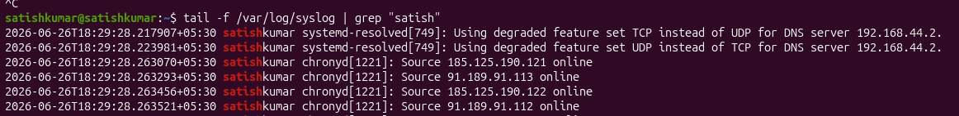
- Set up a web server (e.g., Apache or Nginx).
Objective
To install and start the Apache web server.
Commands Executed
Install nginix:
sudo apt install nginx
Check status:
sudo systemctl status nginx
Command Output/Result
Apache service is active and running.
Key Learnings/Notes
- Apache is a popular web server.
- systemctl is used to manage services
To check running web server
Command: sudo lsof -I :80

To check stop running web server
Command: sudo systemctl stop nginx

To check run web server
Command : sudo systemctl start apache2

To check status of running server
Command : sudo systemctl status apache2

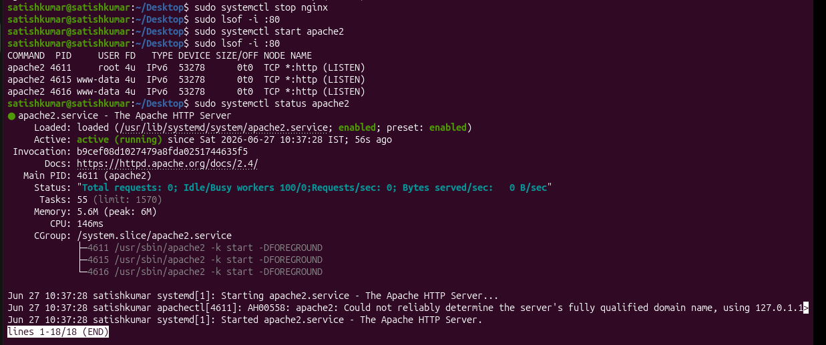

- Configure and secure a MySQL Database.
Objective
To install and secure the MySQL database server.
Commands Executed
Install MySQL:
sudo apt install mysql-server -y
Secure installation:
sudo mysql_secure_installation
Check status:
sudo systemctl status mysql
Login:
mysql -u root -p
Command Output
MySQL server starts successfully and accepts login credentials.
Evidence (Screenshots)
Key Learnings
- MySQL stores application data.
- mysql_secure_installation improves database security.
To search packages
Command : apt search mysql-server
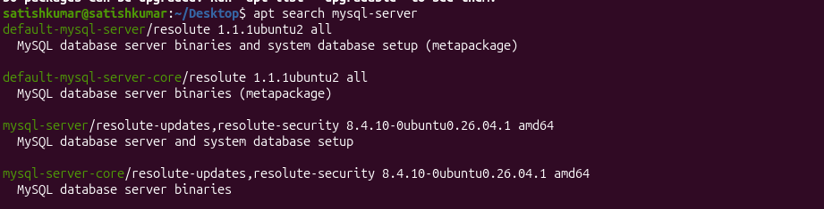
Install
Command : sudo apt install mysql-server -y
sudo → Administrator privileges.
apt → Package manager.
install → Install the package.
mysql-server → MySQL Database Server package.
-y → Automatically confirms installation.
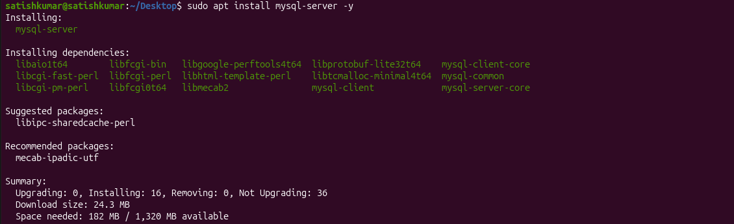

- Set up a Application Server (e.g.,Apache Tomcat)
Objective
To install and configure Apache Tomcat for running Java web applications.
Commands Executed
Download Tomcat:
wget https://dlcdn.apache.org/tomcat/tomcat-9/v9.0.119/bin/apache-tomcat-9.0.119.tar.gz
Extract:
tar -xvf apache-tomcat*.tar.gz
Start Tomcat:
cd apache-tomcat*/bin
./startup.sh
Command Output
Tomcat starts successfully.
Open:
http://localhost:8080
The Tomcat welcome page appears.
Key Learnings
- Tomcat is a Java application server.
- Used for deploying Java web applications.
Step 1: Install Java
sudo apt update
sudo apt install default-jdk -y

We need to install java to run Apache tomcat
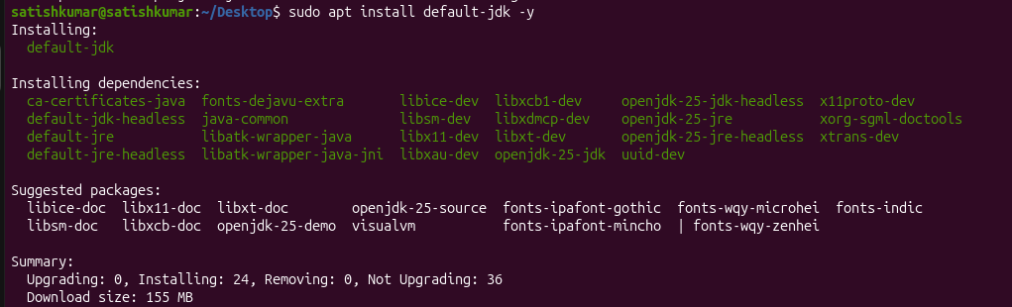
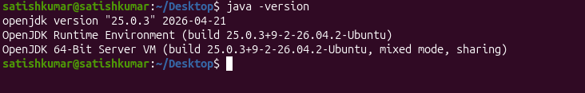
Step 2: Create a Tomcat User
Instal Apache tomcat10
Command : sudo apt install tomcat10 -y
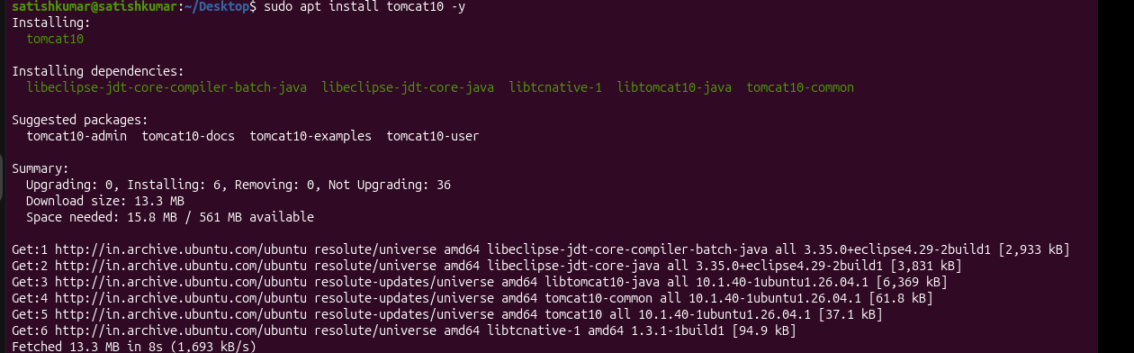
- create a service file for Apache Tomcat.(Should execute by using systemtctl command)
Objective
To manage the Apache Tomcat server using the systemctl command.
Commands Executed
sudo apt update
sudo apt install openjdk-17-jdk -y
java -version
cd /opt
sudo tar -xvf apache-tomcat-9.0.119.tar.gz
sudo mv apache-tomcat-9.0.119 tomcat
sudo chmod +x /opt/tomcat/bin/*.sh
Create the Tomcat Service File
sudo nano /etc/systemd/system/tomcat.service
Save and exit (Ctrl + O, Enter, Ctrl + X).
Reload systemd and start the service:
sudo systemctl daemon-reload
sudo systemctl enable tomcat
sudo systemctl start tomcat
sudo systemctl status tomcat
Command Output/Result
- Java 17 installed successfully.
- Tomcat service file created successfully.
- systemctl daemon-reload completed successfully.
- Tomcat service enabled to start automatically at boot.
- systemctl status tomcat displayed Active: active (running).
Key Learnings/Notes
- A systemd service file allows Tomcat to be managed using systemctl.
- Tomcat can be started, stopped, restarted, and checked with simple commands.
- Enabling the service ensures Tomcat starts automatically after every system boot.
- Using systemd makes Tomcat administration easier and more reliab
Step 1: Find JAVA_HOME
Command : readlink -f $(which java)

Service file
Command : systemctl cat tomcat10
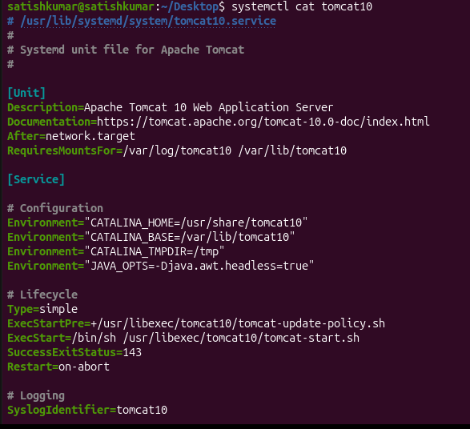
Status
Command : sudo systemctl status tomcat10
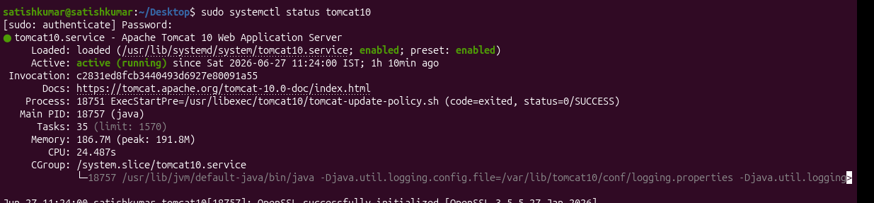
Stop services
Command : sudo systemctl stop tomcat10

Restart services
Command: sudo systemctl start tomcat10
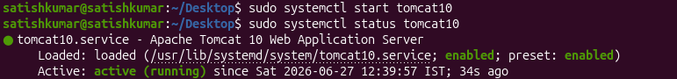

- Print specific columns from a delimited file.
Objective
To extract and display specific columns from a text file using the awk command.
Commands Executed
Create a sample file:
touch employee.csv
cat > employee.csv
Command : cut -d “ “ -f2 employee.csv
Print the Name column:
awk -F',' '{print $2}' employee.csv
Command Output
A
B
C

Key Learnings
What is a Delimited File?
A delimited file is a file where data is separated by a specific character called a delimiter
Command : cut -d “ “ -f2 employee.csv
cut → Extract specific columns from a file.
-d → Specifies the delimiter.
-f → Specifies the field (column) number.
Print 2nd column:
cut -d "," -f2 employee.csv
Print 2nd and 4th columns:
cut -d "," -f2,4 employee.csv
Print 1st column from /etc/passwd:
cut -d ":" -f1 /etc/passwd

Delimiter | Example
Comma , | emp.csv
Colon : | /etc/passwd
Tab \t | TSV files
Pipe ` | `
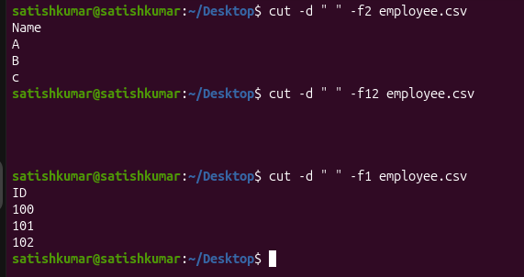

- Filter and print lines based on a specific pattern or condition.
Objective
To display lines matching a specific pattern.
In Linux, the grep command is used to search and print lines that match a specific pattern.

Commands Executed
grep "Devops" employee2.csv
Command Output
1 alpha Devops 500
Key Learnings
- grep searches text.
- Useful for log analysis.
Command : grep "devops" employee.txt
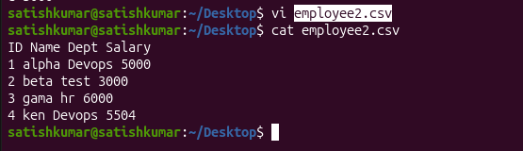
Create a Sample File

Print Lines Containing "DevOps"
Command : grep “Devops ” employee2.csv
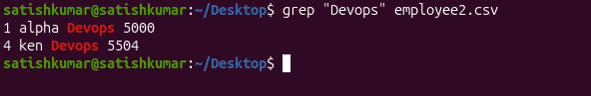
Print Lines Containing "beta"

Ignore Uppercase/Lowercase
Command : grep -i "devops" employee.txt

- Calculate and print the average, sum, or other statistics of a column.
In Linux, the awk command is commonly used to perform calculations on columns.
Calculate the Sum of Salaries
Objective
To calculate salary statistics using AWK.
Commands Executed
Average:
awk -F',' '{sum+=$4} END {print sum/NR}' employee2.csv
Sum:
awk -F',' '{sum+=$4} END {print sum}' employee2.csv
Key Learnings/Notes
- NR stores total number of records.
- AWK performs calculations easily.
Command : awk

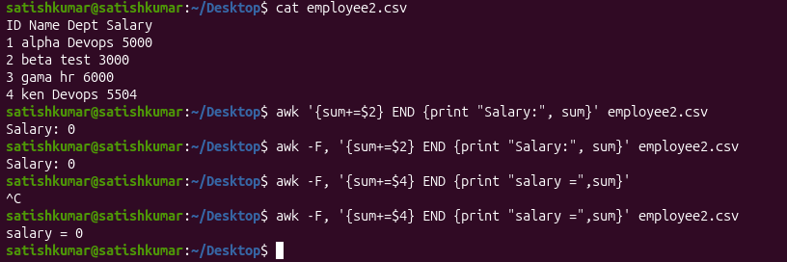

- Perform string manipulation, such as extracting substrings or changing case.
Objective
To manipulate text by extracting specific characters (substrings) or converting text to
uppercase/lowercase using the awk command.
Commands Executed
Command : cut -c2-5 names.txt
Command : cut -c2-5 names.txt
Command : cut -c2-5 names.txt
Key Learnings
- toupper() converts text to uppercase.
- tolower() converts text to lowercase.
- substr(string, start, length) extracts a portion of a string.
- AWK is commonly used for text processing and data formatting.
- In Linux, string manipulation is commonly done using:
- cut
- awk
- tr
- sed

Method 1: Using cut (Extract Substring)
Step 1: Create a File
Command : cut -c2-5 names.txt
Explanation
- cut → Extract characters
- -c → Character position
- 1-3 → Characters from position 1 to 3

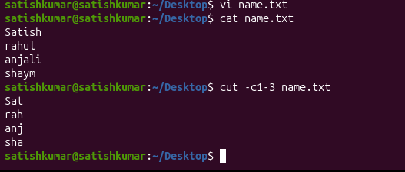
Extract Characters 2 to 5

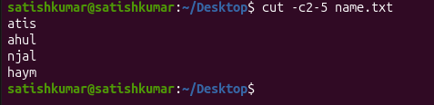
Command : cut -c2-5 names.txt

To create file
Command: echo "linux devops" > text.txt
Convert Lowercase to Uppercase
Command : cat text.txt | tr ‘a-z’ ‘A-Z’
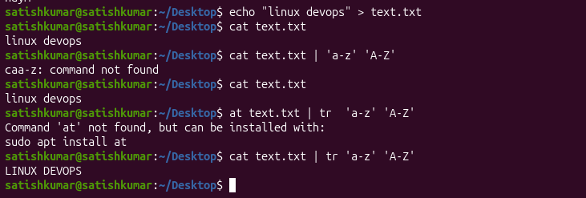

Convert Uppercase to Lowercase
Command : cat text.txt | tr ‘A-Z’ ‘a-z’

Using awk (Extract Characters)
Print first 3 characters:
Command : awk '{print substr($1,1,3)}' names.txt
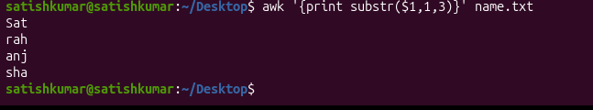
Using sed (Replace String)
Replace "DevOps" with "Linux":
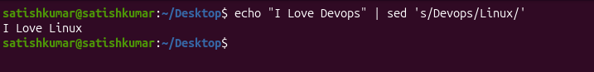
Command : echo "I Love DevOps" | sed 's/DevOps/Linux/'

- Count the occurrences of a specific pattern in a file.
In Linux, the grep command is used to count how many times a pattern appears in a file
Objective
To count how many times a specific pattern or word appears in a file using the grep command.
Commands Executed
Count the occurrences of the pattern IT:
Command : vi employee.txt
Command : grep -c "DevOps" employee.txt
Command : grep -o "DevOps" employee.txt | wc -l
Command Output/Result
Output of grep -c:
303
Output of grep:
404
Key Learnings/Notes
- grep searches for a specific pattern in a file.
- -c counts the number of matching lines.
- Useful for analyzing log files, configuration files, and text data.
- Step 1: Create a Sample File
Command : vi employee.txt

Method 1: Count the Number of Matching Lines (grep -c)
Explanation
- grep → Search for a pattern.
- -c → Count the number of matching lines.
- "DevOps" → Pattern to search.
- employee.txt → File name.

Command : grep -c "DevOps" employee.txt
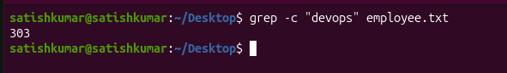
Method 2: Count Every Occurrence (grep -o | wc -l)
Command : grep -o "DevOps" employee.txt | wc -l

- Sort lines based on a specific field or column.
Step 1: Create a Sample File
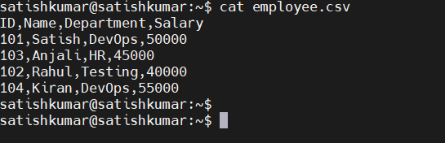

Method 1: Sort by ID (1st Column)
Command : sort -t "," -k1 employee.csv
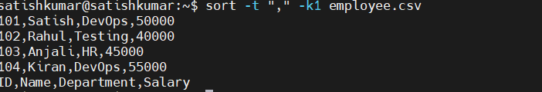
Method 2: Sort by Name (2nd Column)
Command : sort -t "," -k2 employee.csv
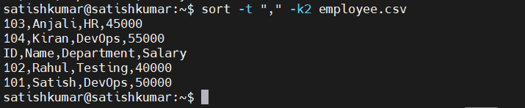
Method 3: Sort by Salary (4th Column - Numeric)
Command : sort -t "," -k4 -n employee.csv
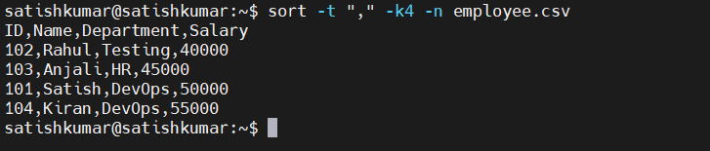
Explanation
- sort → Sort data.
- -t "," → Comma is the delimiter.
- -k4 → Sort by the 4th column.
- -n → Numeric sort.

Method 4: Sort Salary in Descending Order
Command : sort -t "," -k4 -nr employee.csv
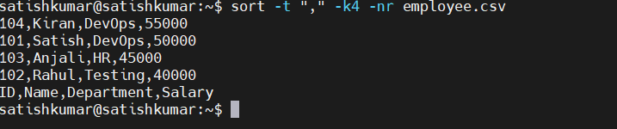
Method 5: Keep the Header at the Top
Command : (head -n 1 employee.csv && tail -n +2 employee.csv | sort -t "," -k4 -n)
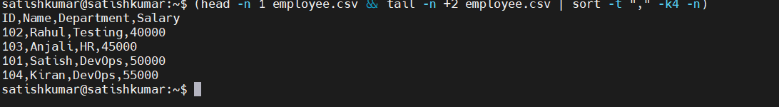

- Merge multiple files based on a common field or column.
In Linux, the join command is used to merge two files based on a common field (column).
Note: The files must be sorted on the common field before using join.
Step 1: Create the First File
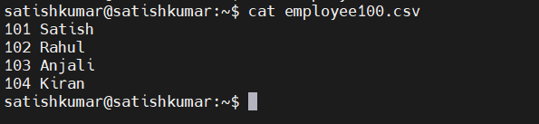
Step 2: Create the Second File
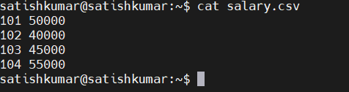
Step 4: Sort Both Files
Command : join employee100.csv salary.csv
- Substitute text in a file using search and replace.
In Linux, the sed (Stream Editor) command is used to search and replace text in a file.
Step 1: Create a Sample File
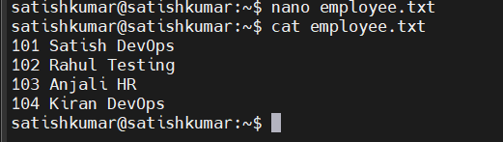
Command : nano employee.txt

Method 1: Replace Text (Display Only)
Command : sed 's/DevOps/Linux/' employee.txt
Replace DevOps with Linux:
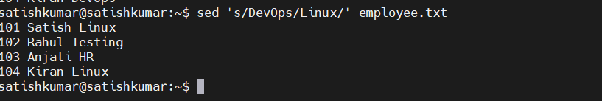
Note: This only displays the changed output. The original file is not modified.
Explanation
- sed → Stream Editor
- -i → Edit the file in place (permanently)
- s → Substitute
- DevOps → Text to search
- Linux → Replacement text

Method 2: Replace Text in the File (Permanent)
Command : sed -i 's/DevOps/Linux/' employee.txt
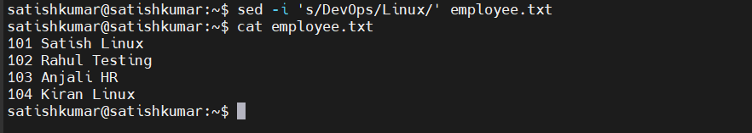
Method 3: Replace All Occurrences in a Line
Command : sed 's/DevOps/Linux/g' employee.txt
Suppose the file contains:
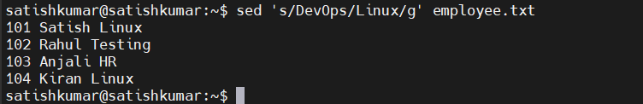
Method 4: Ignore Uppercase/Lowercase
sed -i 's/devops/Linux/Ig' employee.txt

Method 5: Replace Only a Specific Line
Replace text only on line 2:
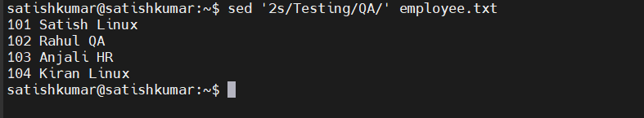
Command Summary
Display replacement only
sed 's/old/new/' filename
Permanent replacement
sed -i 's/old/new/' filename
Replace all occurrences
sed -i 's/old/new/g' filename
Replace only on line 3
sed '3s/old/new/' filename
- Delete specific lines based on a pattern or line number.
In Linux, you can delete lines using:
- sed → Delete by line number or pattern (most common)
- awk → Filter out lines
- grep -v → Remove lines matching a pattern (display only)
Method 1: Delete a Specific Line Number
sed '3d' employee.txt

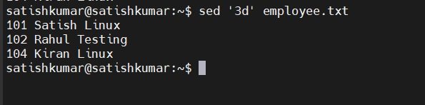
Method 2: Delete Line 3 Permanently
sed -i '3d' employee.txt
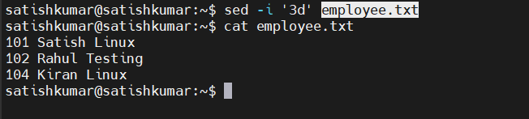
Method 3: Delete Multiple Lines
Delete lines 2 to 4:
sed '2,4d' employee.txt
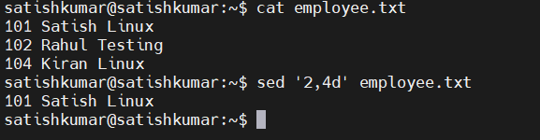
Method 4: Delete Lines Matching a Pattern
Delete all lines containing DevOps:
sed '/DevOps/d' employee.txt
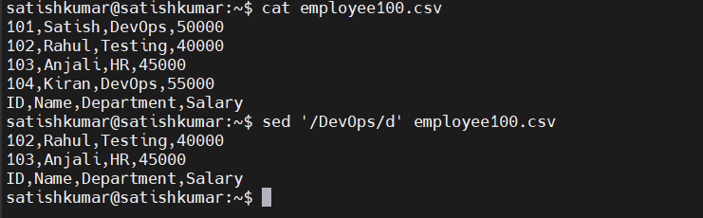
Method 5: Delete Blank Lines
sed '/^$/d' employee.txt
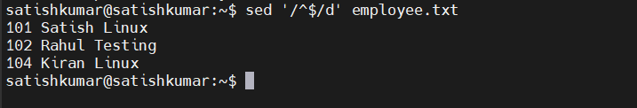
Method 6: Delete the First Line
sed '1d' employee.txt
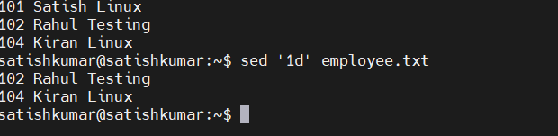
Method 7: Delete the Last Line
sed '$d' employee.txt
last line ID deleted
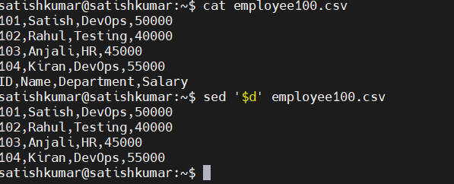

Method 8: Using grep -v
Remove all lines containing Testing (display only):
grep -v "Testing" employee.txt
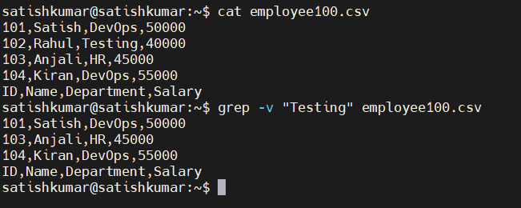
Command Summary
Delete line 3:
sed '3d' employee.txt
Delete lines 2–4:
sed '2,4d' employee.txt
Delete pattern:
sed '/DevOps/d' employee.txt
Delete permanently:
sed -i '/DevOps/d' employee.txt
Delete blank lines:
sed '/^$/d' employee.txt
Delete last line:
sed '$d' employee.txt

Delete line 3:
sed '3d' employee.txt

Delete lines 2-4:
sed '2,4d' employee.txt

Delete lines containing "DevOps":
sed '/DevOps/d' employee.txt

Delete permanently:
sed -i '/DevOps/d' employee.txt

Delete first line:
sed '1d' employee.txt

Delete last line:
sed '$d' employee.txt

Delete blank lines:
sed '/^$/d' employee.txt

Display lines NOT containing "Testing":
grep -v "Testing" employee.txt

- Append or insert text before or after a specific pattern or line.
Method 1: Insert Text Before Line Number
Insert a header before line 1:
sed '1i Employee Details' employee.txt
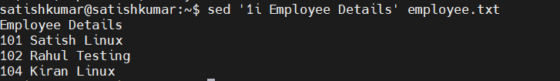
Explanation
- 1 → Line number
- i → Insert before the line
Method 2: Append Text After Line Number
Append text after line 2:
sed '2a ----------------' employee.txt
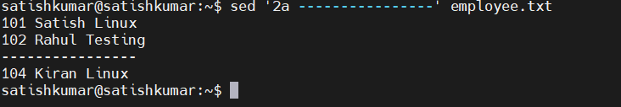
Method 3: Insert Before a Pattern
Insert before every line containing Rahul:
sed '/Rahul/i Employee Found' employee.txt
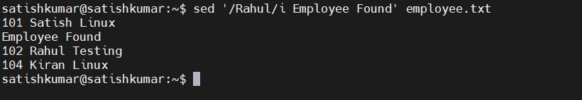
Method 4: Append After a Pattern
Append after every line containing Rahul:
sed '/Rahul/a Promotion Eligible' employee.txt
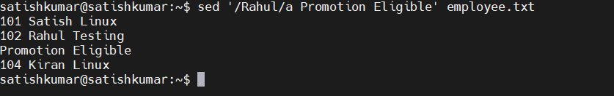
Command Summary
Insert before line 1
sed '1i Employee Details' employee.txt
Append after line 2
sed '2a ----------------' employee.txt
Insert before pattern
sed '/Rahul/i Employee Found' employee.txt
Append after pattern
sed '/Rahul/a Promotion Eligible' employee.txt
Permanent change
sed -i '/Rahul/a Promotion Eligible' employee.txt

- Print only specific lines from a file.
In Linux, you can print specific lines using:
- sed (most common)
- awk
- head + tail
Method 1: Print a Specific Line (Most Common)
Print line 3:
sed -n '3p' employee.txt
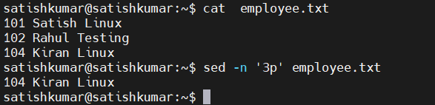
Method 2: Print Multiple Lines
Print lines 2 to 4:
sed -n '2,4p' employee.txt
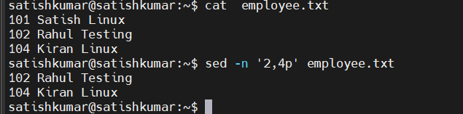
Method 3: Print the First Line
sed -n '1p' employee.txt
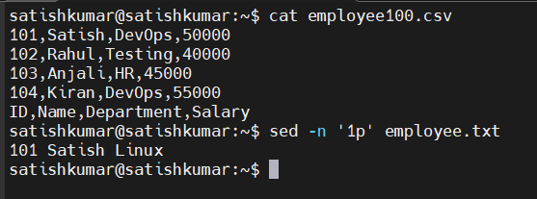
Method 4: Print the Last Line
sed -n '$p' employee.txt
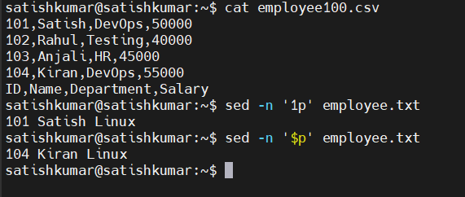

Command Summary
Print line 3
sed -n '3p' employee.txt
Print lines 2 to 4
sed -n '2,4p' employee.txt
Print last line
sed -n '$p' employee.txt
Using awk
awk 'NR==3' employee.txt

- Copy file from Linux to windows machine
To copy a file from Linux to your Windows machine using MobaXterm
Let's use employee.csv as an example.
Step 1: Check the current path
pwd
Output:
/home/satishkumar
Step 2: Verify the file exists
ls -l employee.csv
or
cat employee.csv
Step 3: Download the file
Since you're using MobaXterm:
- Look at the left side of the MobaXterm window.
- You'll see the SFTP panel.
- Open the folder home → satishkumar.
- Find employee.csv.
- Drag and drop it to your Windows Desktop or any folder.
OR
- Right-click employee.csv
- Select Download
- Choose the destination folder in Windows.

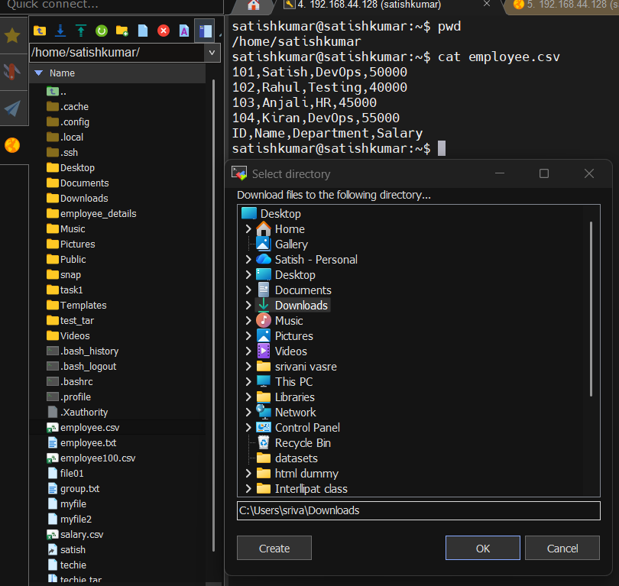

- 5 use cases for AWK and 5 use cases for sed
42: 5 use cases for AWK and 5 use cases for sed
5 Use Cases of AWK
1. Print specific columns from CSV or text files.
2. Filter records based on a condition.
3. Calculate the sum, average, minimum, or maximum of a column.
4. Perform string operations such as converting text to uppercase/lowercase or extracting
substrings.
5. Generate formatted reports from log files or structured data.
5 Use Cases of SED
1. Search and replace text in a file.
2. Delete lines based on a line number or pattern.
3. Insert or append text before or after a specific line.
4. Print selected lines from a file.
5. Edit configuration or log files automatically without opening a text editor

